USB Device Control &
Monitoring Framework
Detailed Project Report
Submitted By | Aneesha Jimmis
Course | CyberSecuirty Internship
Institution | Unified Mentor
Platform | Kali Linux (VirtualBox) | macOS Host
Date | 10 June 2026

Abstract
USB devices are widely used for data transfer and peripheral connectivity. However, they pose significant security risks including unauthorized access, malware propagation, and data exfiltration. This project presents a USB Device Control & Monitoring Framework developed using Python 3 on Kali Linux running in VirtualBox on a macOS host.

The framework detects USB device insertion and removal events in real time using pyudev, identifies connected devices using vendor ID, product ID, and serial number, verifies devices against a JSON allowlist, logs all USB and file activities with timestamps, monitors file operations using watchdog, generates SHA256 hashes for file integrity verification, and produces a security report on session exit. The project demonstrates practical endpoint security and defensive blue-team techniques.

Objectives
- Detect USB connect and disconnect events in real time
- Extract and log device Vendor ID, Product ID, and Serial Number
- Implement allowlist-based authorization (allowlist.json)
- Flag and log unauthorized device connection attempts
- Monitor file activities (creation, modification, deletion) in USB directory
- Generate SHA256 hashes for file integrity verification
- Produce timestamped audit logs (usb_audit.log) and security reports (report.txt)

Technologies Used
Component | Details
Language | Python 3
USB Monitoring | pyudev — monitors USB events via Linux kernel netlink socket
File Monitoring | watchdog — filesystem event handler (FileSystemEventHandler)
Integrity Hashing | hashlib — SHA256 hash generation for file auditing
Logging | logging — timestamped audit log written to usb_audit.log
Date/Time | datetime — used in report generation for timestamps
Platform | Kali Linux (VirtualBox) running on macOS Apple Silicon host
USB Passthrough | VBoxManage controlvm usbattach command on macOS host terminal

System Architecture
The framework is structured into seven modules, each handling a distinct function:

Module | Description
USB Detection | pyudev.Monitor listens for USB subsystem events in real time
Device Fingerprinting | Extracts ID_VENDOR_ID, ID_MODEL_ID, ID_SERIAL_SHORT from device context
Allowlist Verification | Compares extracted IDs against allowlist.json; flags unknown devices
Audit Logging | All events written to usb_audit.log with asctime format
File Monitoring | watchdog Observer watches ./test_usb/ directory recursively
SHA256 Hashing | hashlib.sha256() generates file hashes on create and modify events
Report Generation | On KeyboardInterrupt (Ctrl+C), summary written to report.txt

Workflow
- Monitor USB ports — detect real-time connect/disconnect events
- Identify USB device — extract Vendor ID, Product ID, Serial Number
- Authorization check — compare against allowlist.json
- Enforcement — allow authorized devices; log and alert on unauthorized ones
- File auditing — watchdog monitors file creation, modification, deletion
- Reporting — generate final USB security report on session exit

Module Descriptions

Module 1: USB Device Detection
The framework continuously monitors USB events using pyudev. A Monitor object is created from the netlink context and filtered to the USB subsystem. The loop iterates over all incoming events, printing the action type (add, remove, bind, unbind) in real time.

Module 2: Device Fingerprinting
For each relevant USB event, the framework extracts three identifying attributes using pyudev device properties:
- ID_VENDOR_ID — the USB vendor identifier (e.g., 05ac = Apple Inc.)
- ID_MODEL_ID — the USB product/model identifier (e.g., 12a8 = iPhone)
- ID_SERIAL_SHORT — the unique serial number of the device
If the vendor ID is None, the event is skipped (non-storage USB events like hubs are filtered this way).

Module 3: Allowlist Verification
Connected devices are compared against a JSON allowlist (allowlist.json). The allowlist stores approved devices with their vendor, product, and serial fields. A match against all three fields marks the device as authorized; otherwise it is flagged and logged as unauthorized.

Module 4: Audit Logging
All events are logged with timestamps to usb_audit.log using Python's logging module with asctime format. Each entry records the event type (AUTHORIZED / UNAUTHORIZED / File Created / File Modified / File Deleted), action, vendor, product, serial, file path, and SHA256 hash where applicable.

Module 5: File Monitoring
A watchdog Observer is scheduled to recursively monitor the ./test_usb/ directory. A custom USBWatcher class extending FileSystemEventHandler handles three events:
- on_created — triggered when a new file appears in the directory
- on_modified — triggered when an existing file is changed
- on_deleted — triggered when a file is removed
Hidden files (e.g., .test.txt.swp) are filtered out by checking if the path starts with "./test_usb/."

Module 6: SHA256 Integrity Verification
The calculate_hash() function reads a file in 4096-byte chunks and produces a SHA256 hex digest. This hash is logged on file creation and modification events, enabling integrity verification — any content change produces a completely different hash value. This technique is a core component of file integrity monitoring (FIM) in real-world endpoint security.

Module 7: Report Generation
When the user terminates the monitoring session with Ctrl+C (KeyboardInterrupt), the framework automatically generates a summary report and saves it to report.txt. The report includes:
- Report generation timestamp
- Total devices seen, authorized devices, blocked devices
- Files created, modified, and deleted counts
- Reference to usb_audit.log for the complete event log

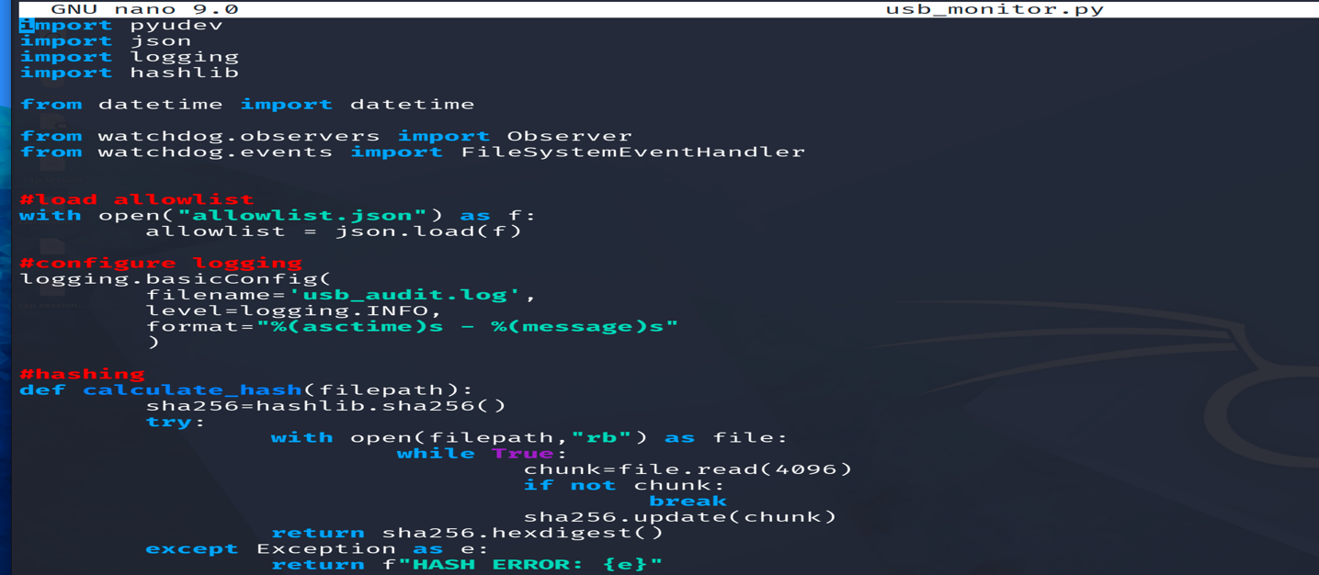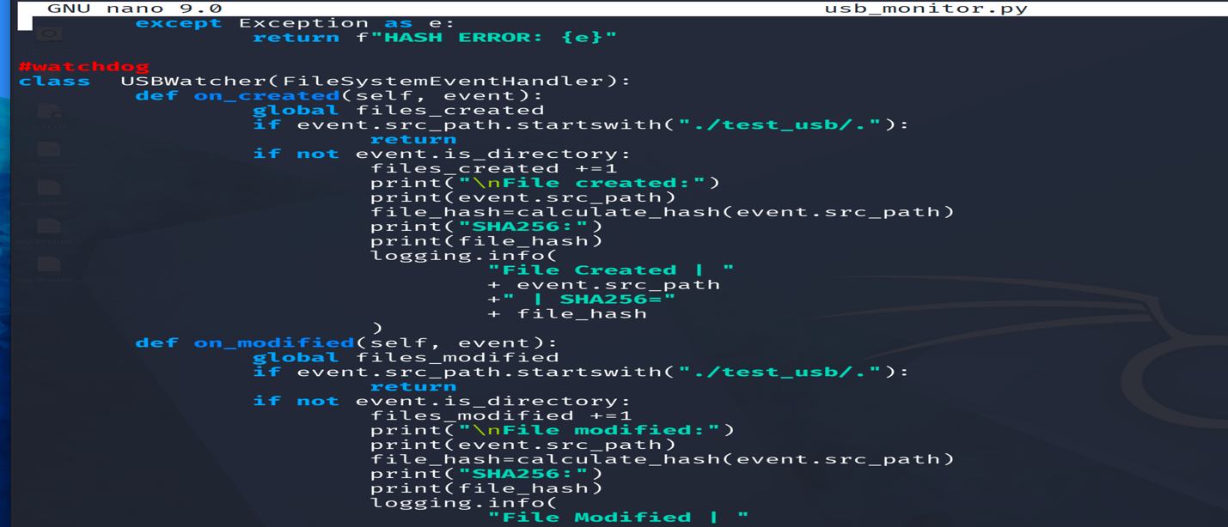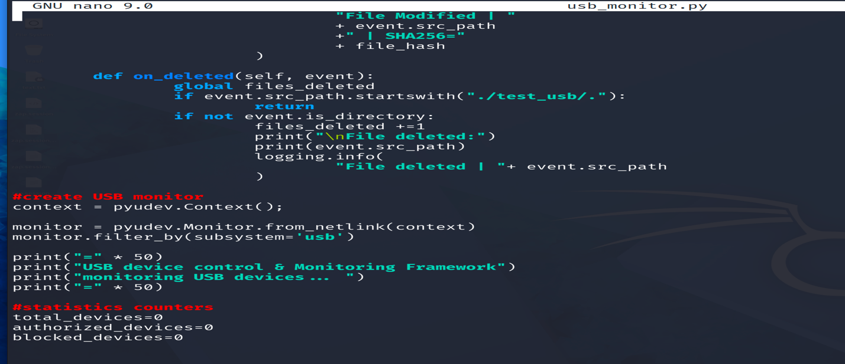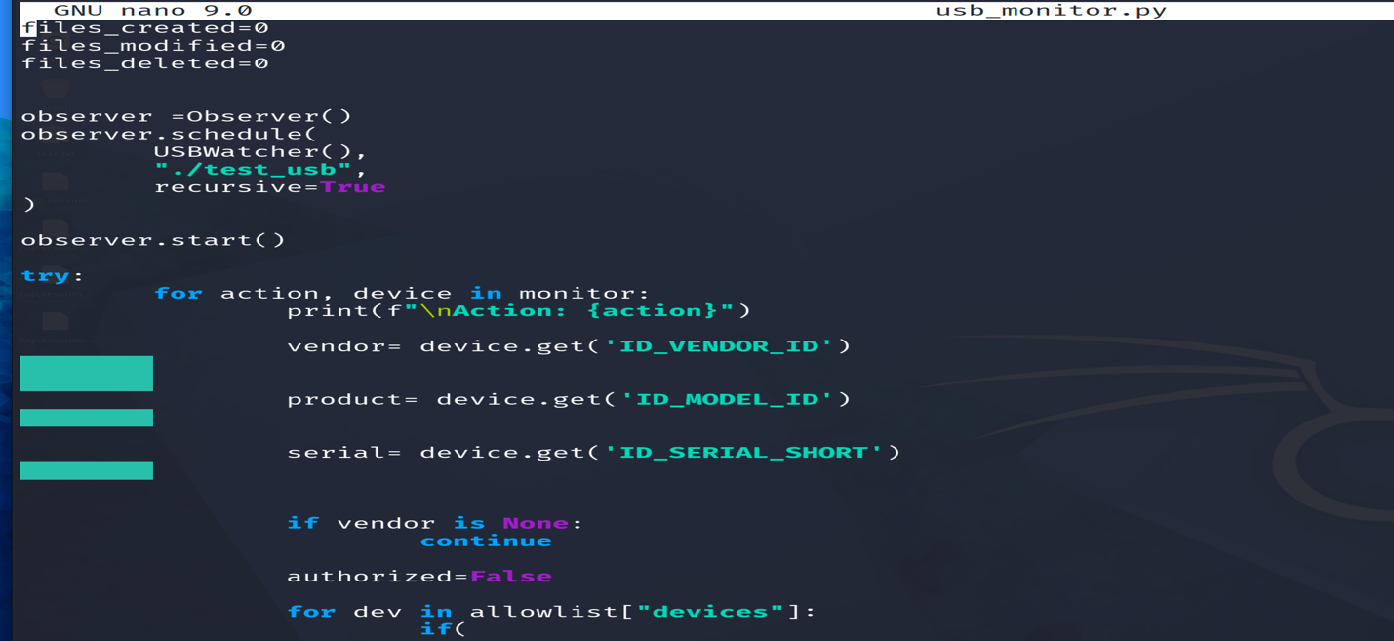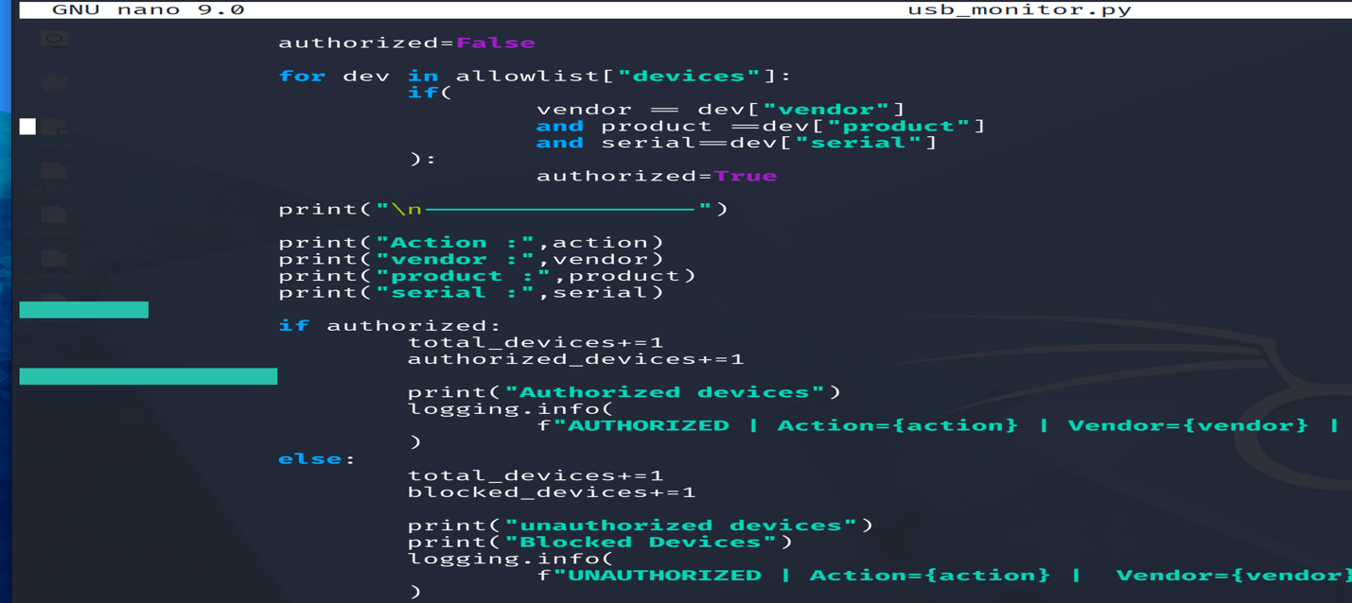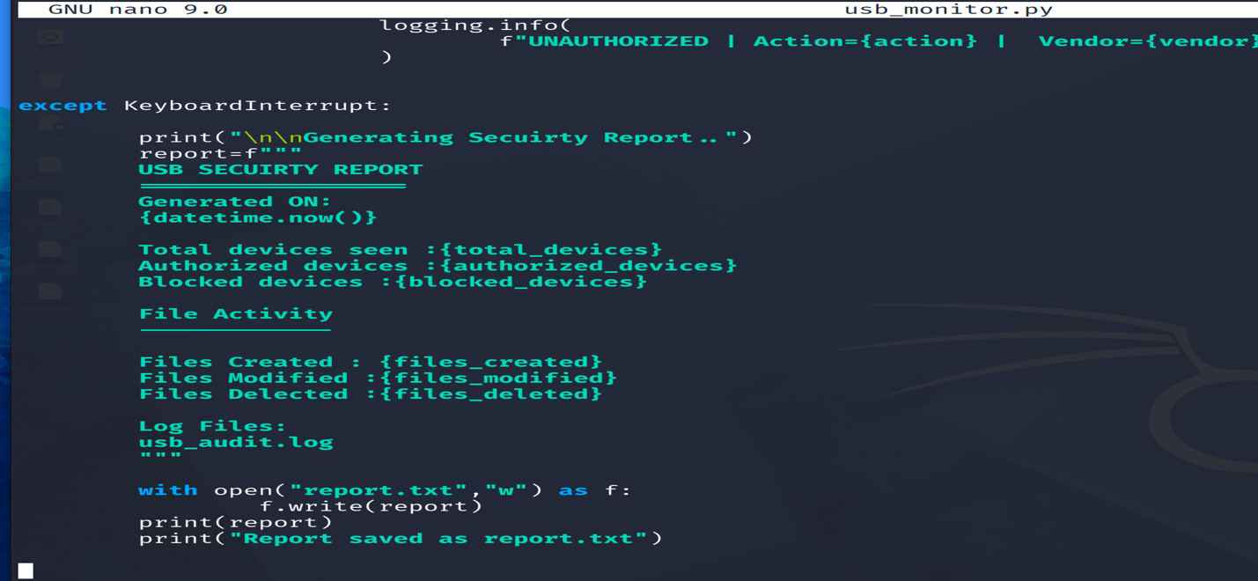

Setup & Execution

Environment
- Host OS: macOS (Apple Silicon — Apple M-series)
- VM: Kali Linux 2026.1 running in VirtualBox
- USB Passthrough: Enabled via VirtualBox Extension Pack

Results

Screenshot 1 — Authorized iPhone Detection
The framework detected the connected iPhone (Apple Inc., VendorID 05ac, ProductID 12a8) and correctly identified it as an authorized device by matching it against the allowlist.json entry. The terminal output shows Action: add → Authorized devices.
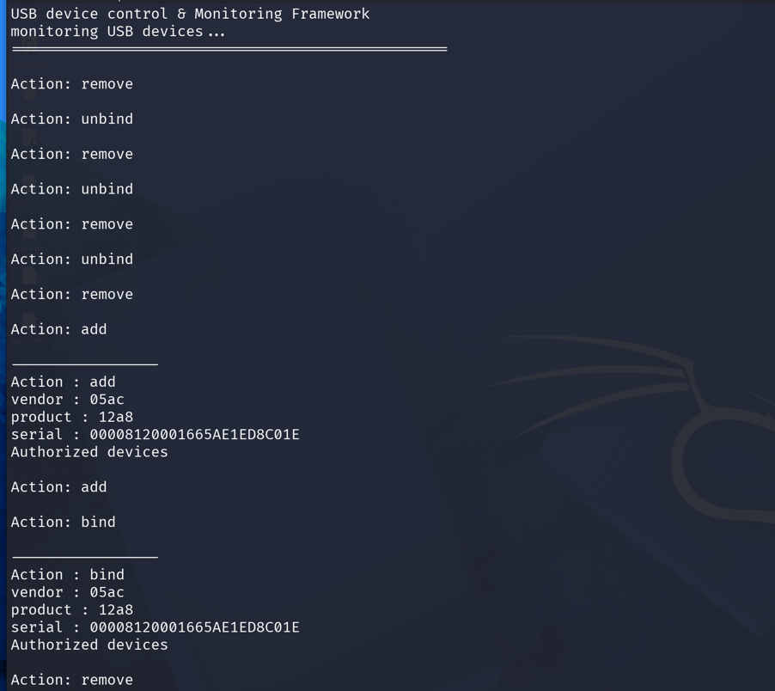

Screenshot 2 — USB Passthrough from macOS to Kali VM
The macOS host terminal shows VBoxManage list usbhost output, confirming the iPhone is visible to the host with VendorId 0x05ac, ProductId 0x12a8, and SerialNumber 00008120001665AE1ED8C01E. The VBoxManage controlvm usbattach command passes it to the running Kali VM, triggering pyudev events.

Since the framework runs inside a VirtualBox VM, the iPhone USB device must be passed from the macOS host to the VM using VBoxManage commands run in the macOS terminal:

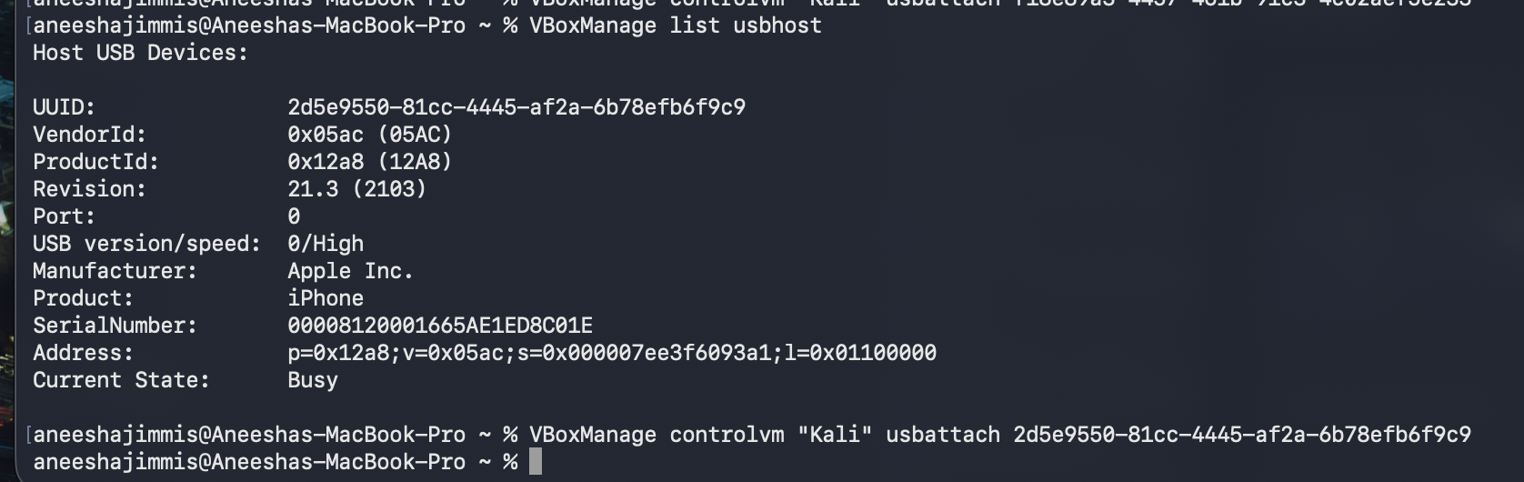
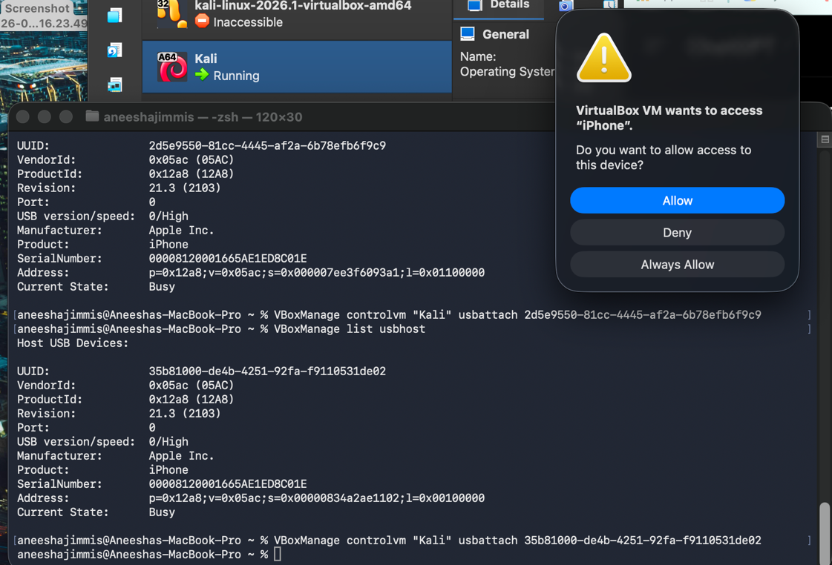

Screenshot 3 — usb_audit.log
The audit log records all events chronologically with millisecond timestamps. Notable entries include:
- AUTHORIZED entries for the iPhone (vendor=05ac, product=12a8)
- UNAUTHORIZED entries for an unrecognized VirtualBox USB device (vendor=80ee)
- File Created, File Modified, and File Deleted events with SHA256 hashes
- Hash errors noted in earlier iterations (fixed in subsequent versions)
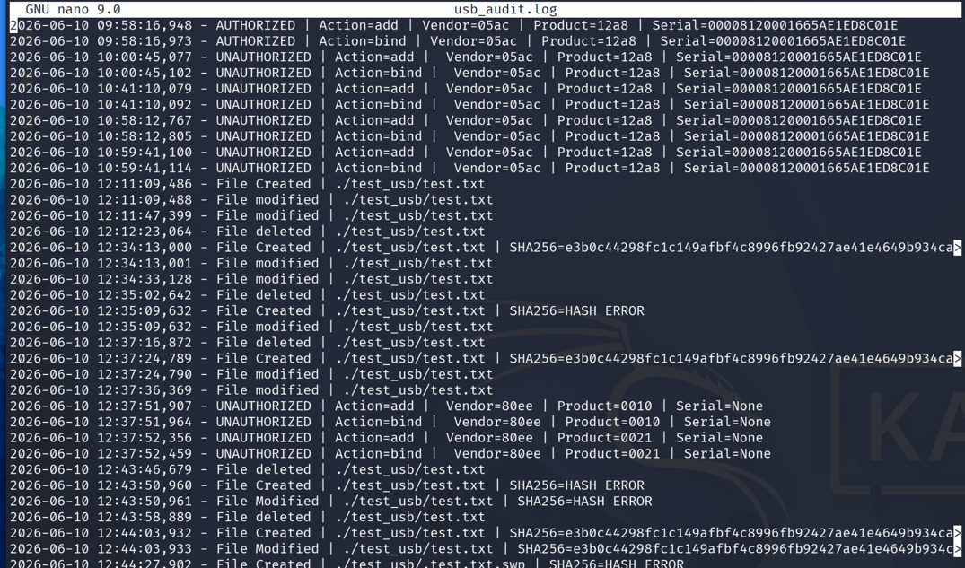
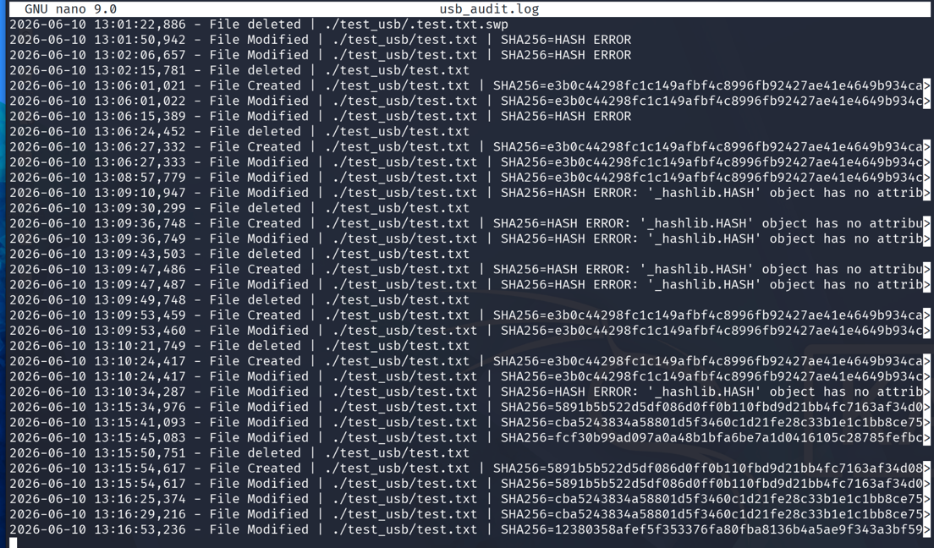

Screenshot 4 — report.txt
The generated report shows: Total devices seen: 0, Authorized: 0, Blocked: 0 (device counts are for the final run session only), Files Created: 1, Files Modified: 7, Files Deleted: 1, with a reference to usb_audit.log.
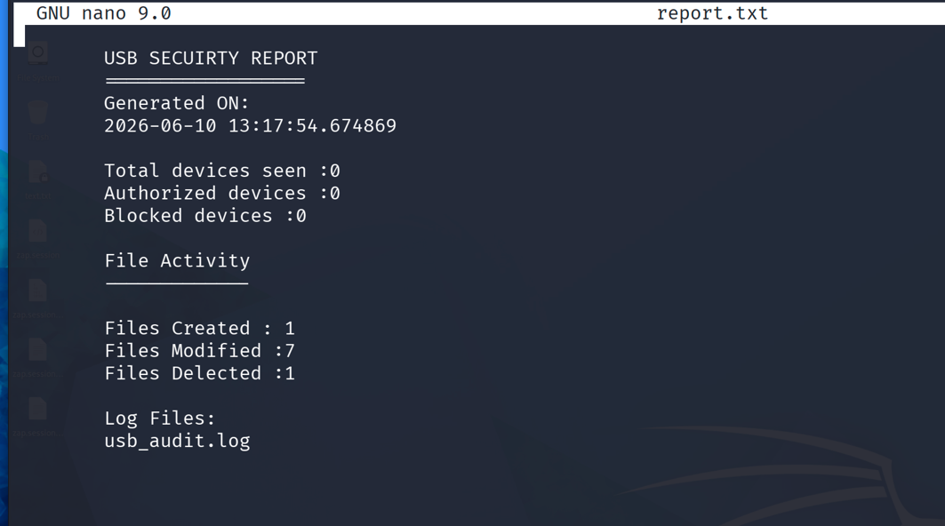

Screenshot 5 — Folder Structure
The project directory (~/Projects/USB) contains: allowlist.json, usb_monitor.py, usb_monitor_backup.py, report.txt, usb_audit.log, and the test_usb/ directory.

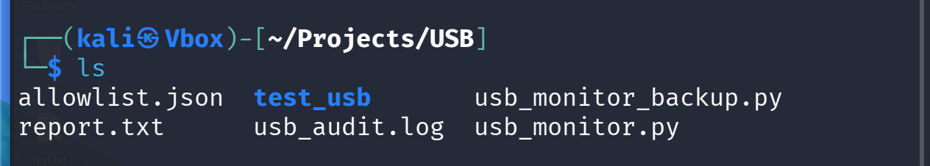

Conclusion
The USB Device Control & Monitoring Framework successfully demonstrates practical endpoint security concepts on Kali Linux. The framework monitors USB hardware events in real time, fingerprints devices using vendor and product identifiers, enforces an allowlist-based authorization policy, audits file operations with SHA256 integrity hashing, and generates a security report on session completion.

The project provides hands-on experience with blue-team defensive techniques including insider threat detection, unauthorized hardware monitoring, and file integrity monitoring — all core skills for a SOC Analyst or Endpoint Security Engineer role.

Future Enhancements
- Real USB blocking using udev rules or kernel module (current implementation logs only)
- Database storage (SQLite or PostgreSQL) for persistent, queryable logging
- Email or Slack alerts on unauthorized device detection events
- Web dashboard interface for real-time monitoring and event visualization
- Windows support using WMI / win32api for enterprise environments
- Integration with SIEM platforms (e.g., Splunk) via syslog forwarding

References
- pyudev documentation: https://pyudev.readthedocs.io/
- watchdog documentation: https://python-watchdog.readthedocs.io/
- Python hashlib documentation: https://docs.python.org/3/library/hashlib.html
- VirtualBox USB passthrough guide: https://www.virtualbox.org/manual/
- Kali Linux documentation: https://www.kali.org/docs/

